MONDAY | TUESDAY | WEDNESDAY  MAVERICKS CAFÉ MENU SCHOOL  May 2026 2025 |  | THURSDAY | FRIDAY | REMINDERS  ~~~~~~~~~~~~~~~~  CEREAL OFFER DAILY  Flavored Fat Free Milk offered daily for Breakfast & Lunch  ~~~~~~~~~~~~~~~~  CHEF SALAD OFFER DAILY  All Grain Products served meets the USDA nutritional whole grain  requirements  ~~~~~~~~~~~~~~  ALL STUDENTS CEP  Midlands Stem Charter School  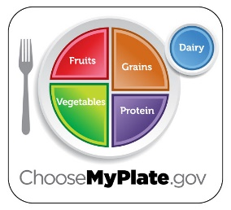  MAVERICKS CAFE  This institution is an equal opportunity provider.  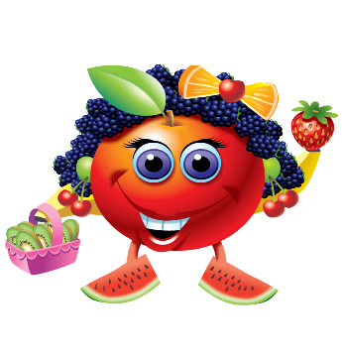  Esta institucion es un proveedor que ofrece igualdad de oportunidades

1
BREAKFAST
Chocolate Chip Muffins
Cereal Bar
Fruit Juice Fruit Cup
Fat Free Milk Choice

LUNCH
PBJ
Baby Carrot /WG Sun Chips
Fresh Orange
4  BREAKFAST  Breakfast Pizza  Fruit Juice Fruit Cup  Fat Free Milk Choice  LUNCH  Flavored Wing Seasoned Fries /Dinner Roll /Green Beans  Oranges/ Flavored Raisins | 5  BREAKFAST  French Toast Sticks  Sausage Links  Fruit Juice Fruit Cup  Fat Free Milk Choice  LUNCH  Cheeseburgers  Lettuce/Tomato Slice / Carrots  Baked Lays Chips  Granny Smith Apples Applesauce  Fat Free Milk Choice | 6  BREAKFAST  Chicken Biscuit  Fruit Juice Fruit Cup  Fat Free Milk Choice  LUNCH  State Fair Corndogs  Sun Chips  Baby Carrot  Bananas / Pineapples |  | 7  BREAKFAST  Assorted Pop-Tart  Assorted Yogurt  Fruit Juice Fruit Cup  Fat Free Milk Choice  LUNCH  Ham/Cheese Sandwich  Baked Potato Chips  Red Grapes Slice Peaches  Fat Free Milk Choice | 8  Breakfast  Ham Cheese Sliders Sandwich  Fruit Juice /Fruit Cup  Fat Free Milk  Lunch  Turkey & Cheese Sandwich  Cheese Puff / Celery Stick  Slice Apple
11  BREAKFAST  Chicken Biscuit  Cereal Bows  Assorted Yogurt  Fruit Juice / Fruit Cup  LUNCH  Hot Dogs w/ Chili  Creamy Cole Slaw  Baked Beans  Grape | 12  BREAKFAST  Pancake w Bacon  Fruit Juice Fruit Cup  Fat Free Milk Choice  LUNCH  Pepperoni Pizza Slice  Mexican Corn / Toss Salads  Fresh Strawberries / Raisins Milk Choice | 13  BREAKFAST  Sausage Biscuit  Fruit Juice/ Fruit Cup  Fat Free Milk Choice  LUNCH  Fish Fillet  Creamy Cole Slaw  WG Sun Chips  Cantaloupe /Pineapple Cup |  | 14  BREAKFAST  Blueberry Breakfast Loaf  Assorted Yogurt  Fruit Juice Fruit Cup  Fat Free Milk Choice  Lunch  Assorted BBQ Sandwich  Baked Beans /  Watermelon Slices / Diced Pears | 15  BREAKFAST  Cereal Bars/Cereal Bowls  R-F Cheese Stick  Fruit Juice Fruit Cup  Fat Free Milk Choice  Lunch  Corn Dogs  Sun Chips  Peach Cup
18  BREAKFAST  Chicken Biscuit /Cereal Bows  R-F Cheese String  Fruit Juice /Fruit Cup  LUNCH  Cheeseburger  Lettuce/Tomato/Pickle  Steam Corn  Orange Wedge/Apple Sauce | 19  Breakfast  Blueberry Muffins  Assorted Cereal /Yogurt  Fruit Juice /Fruit Cup  Lunch  Flavored Chicken Wings / Season  Rice/Lima Bean/Field Peas  Dinner Roll  Strawberry/Grape | 20  BREAKFAST  Sausage Biscuit /Cereal Bars  R-F-Cheese String  Fruit Juice/ Fruit Cup  Fat Free Milk Choice  LUNCH  Pepperoni Pizza Slice  Black Bean/ Toss Salad  Dice Pears/Slice Peach  Fat Free Milk Choice |  | 21  BREAKFAST  Banana Muffin/ Cereal bowl  Yogurt/Graham Cracker  Fruit Juice/Fruit Cup  Lunch  Fish Fillet Sandwich  Baked Fries  Creamy Cole Slaw  Sherbet | 22  BREAKFAST  Cereal Bars/R-F Cheese String  Fruit Cup/Fruit Juice  Lunch  PBJ  Sun Chips / Baby Carrot /Cookies  Fresh Fruit
25  Memorial Day   | 26  Breakfast  Breakfast Pizza  R-F Cheese String  Fruit Juice  Lunch  Crispy Chicken Sandwich  Lettuce/ Tomato/ Pickle  Pineapples |  | 27  Breakfast  Sausage Biscuit  Yogurt  Fresh Fruit  Lunch  PBJ /Sun Chips / Cookie  Fresh Fruit  LAST DAY OF SCHOOL | 28 |   29

